**TC01 - Registration and Add to Cart**

**Step 1 :** Launch Open Cart application <http://10.207.182.108:81/opencart/>

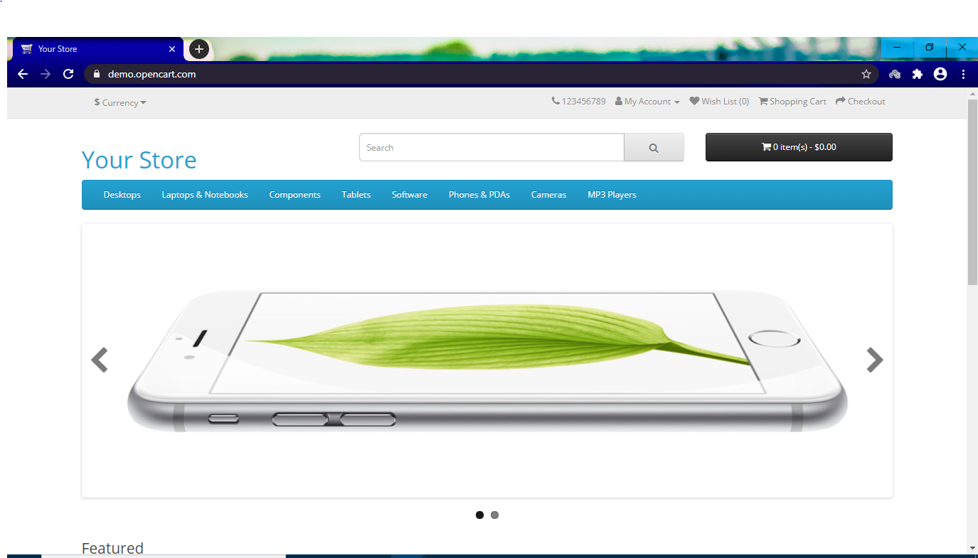

**Step 2 :** Click on "Create an account" link.

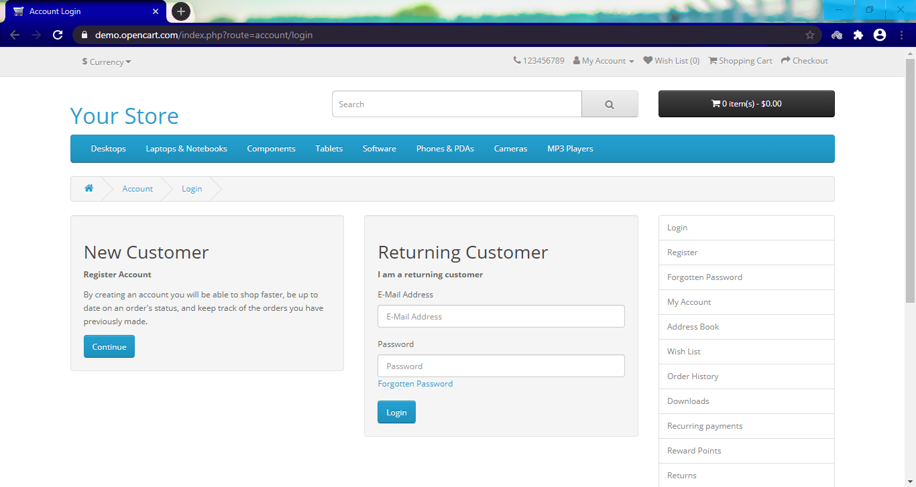

**Step 3 :** Fill in the Details of the page -Name(s), Email, Phone, Company and Address, City, Post Code. Select values from the list for Country and State/Region.

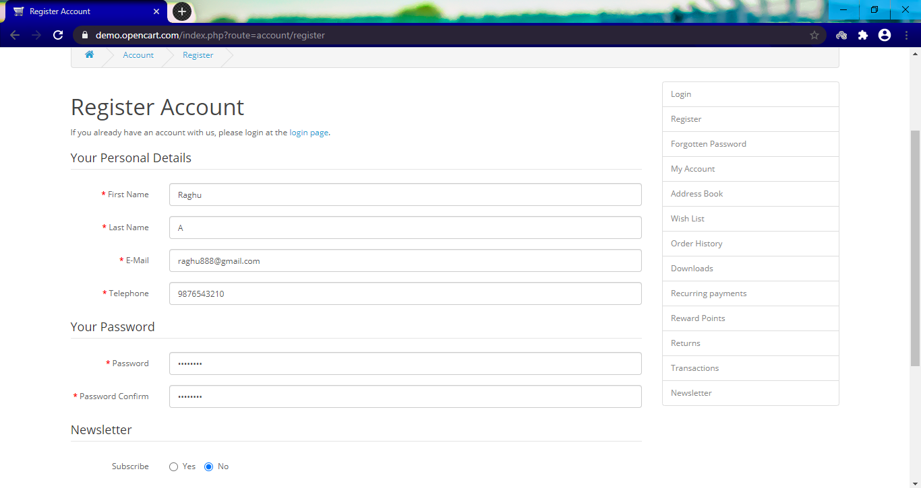

**Step 4 :** Check the "Privacy Policy" and click on "Continue".

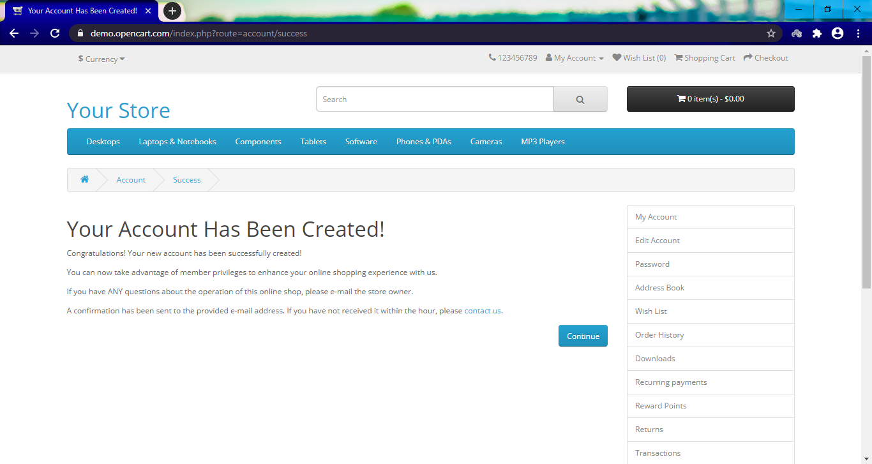

**Step 5 :** Click on "Contact" link.

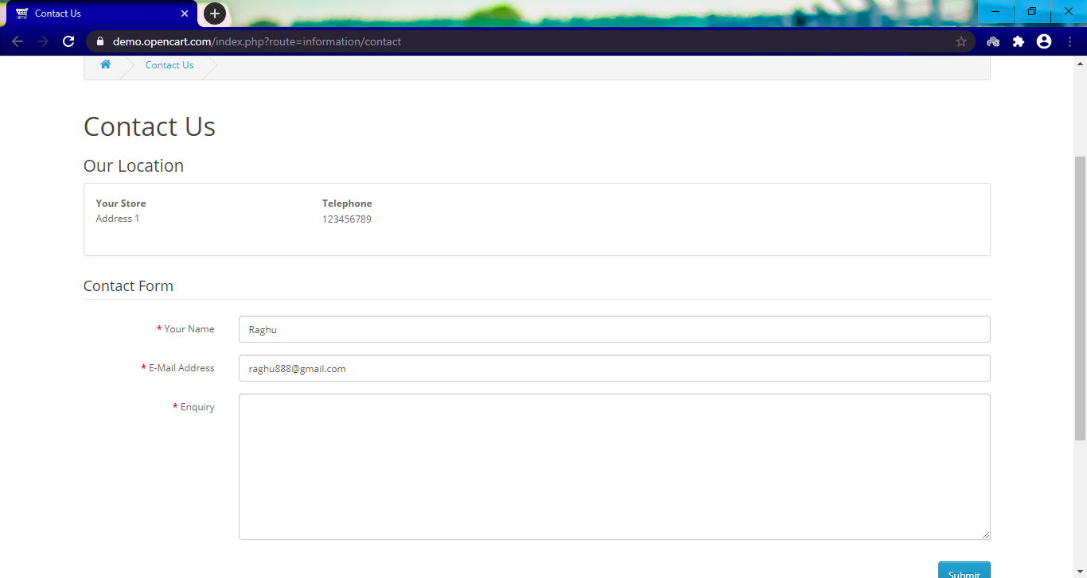

**Step 6 :** Type the Enquiry - 100 characters.

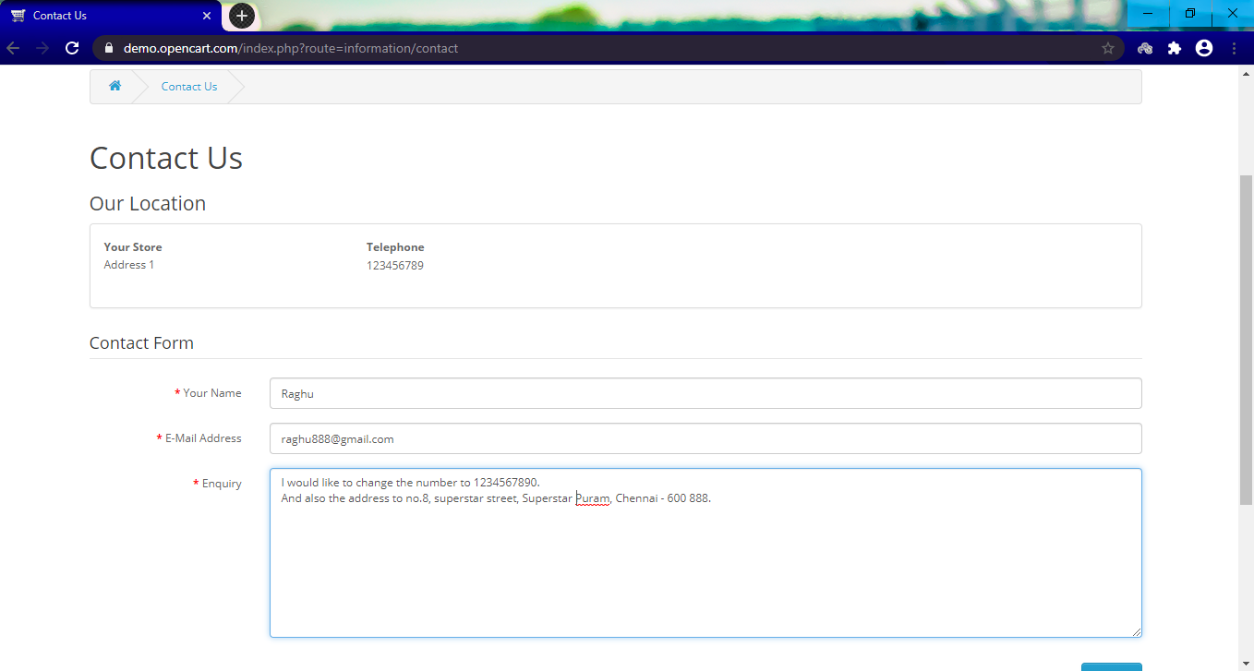

**Step 7 :** Type the "Enter Code" in the textbox

This step is not available in opencart.

**Step 8 :** Click on "Continue" and Click on "Continue".

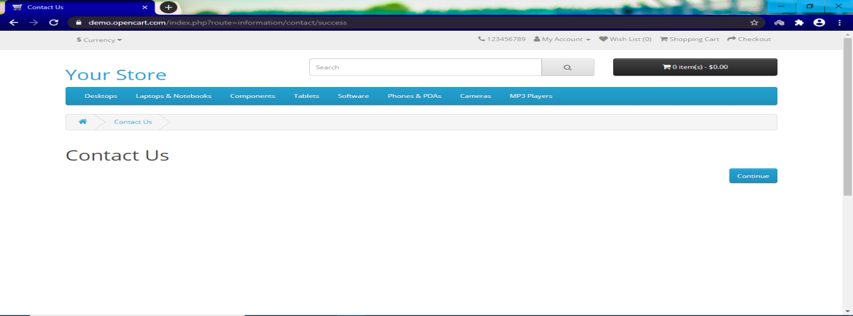

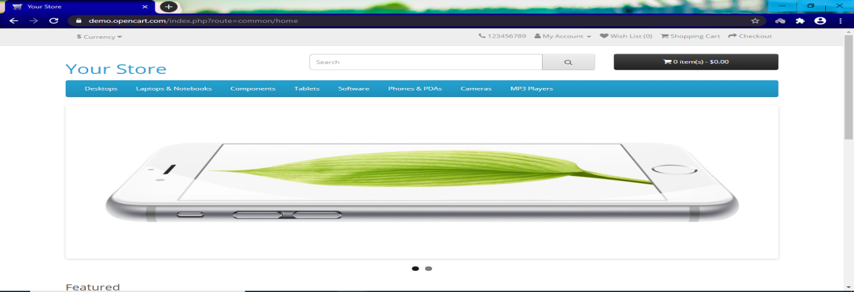

**Step 9 :** Click on "Samsung Galaxy Tab" on home page which is shown as the main advertisement - this might change - but the user should click on this main image only.

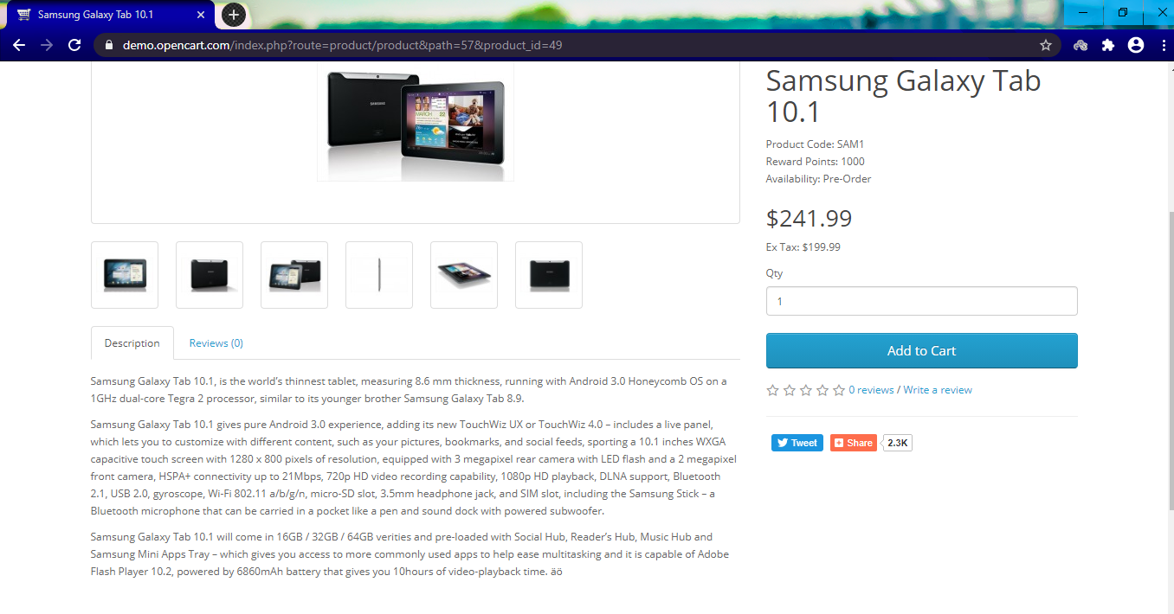

**Step 10 :** Click on "Review" tab below.

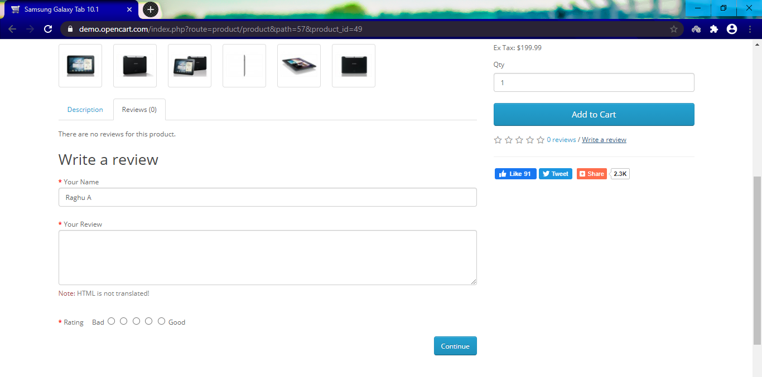

**Step 11 :** Fill in your details -Name and Review. Select the rating as given in Scenario Outline. Enter the code in the box - Click Continue.

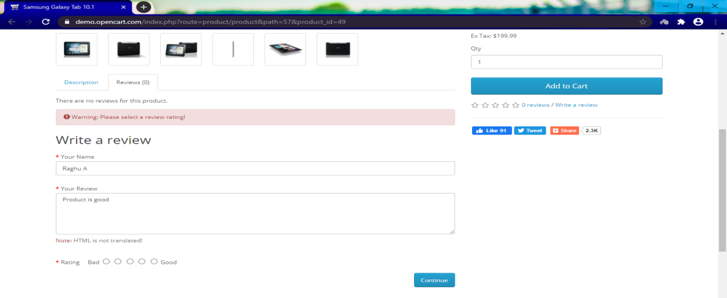

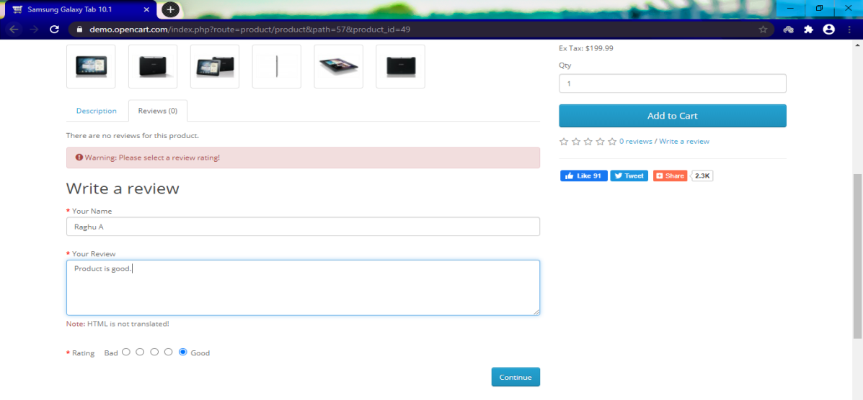

**Step 12 :** Fill in your details -Name and Review. Select the rating as given in Scenario Outline.

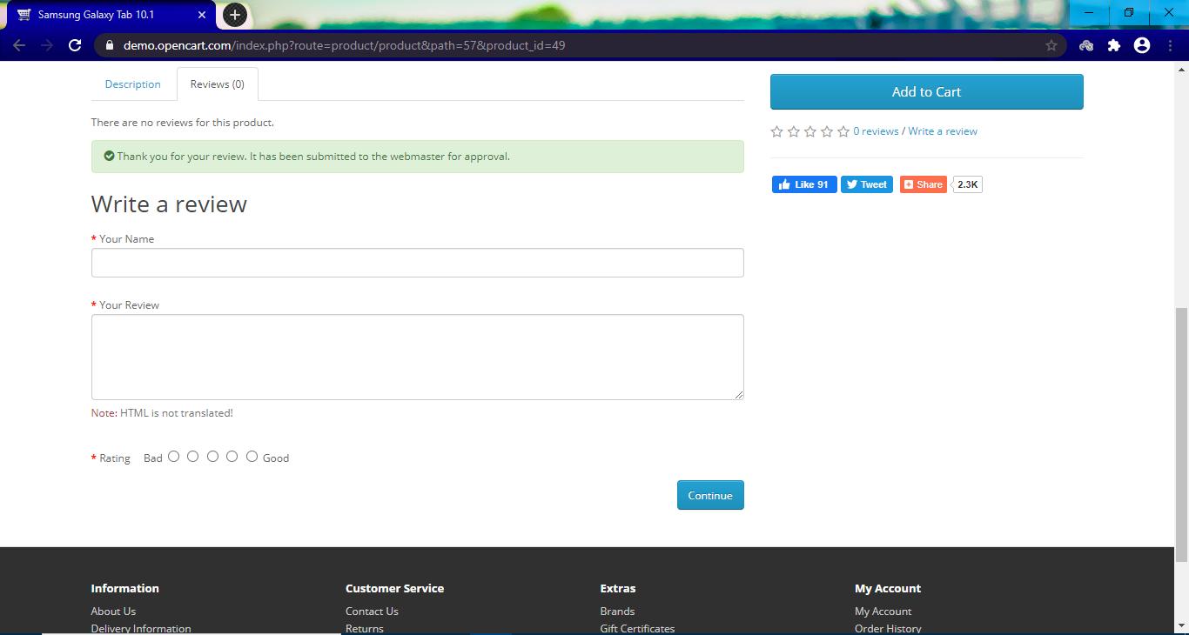

**Step 13 :** Click on "Add to wish list".

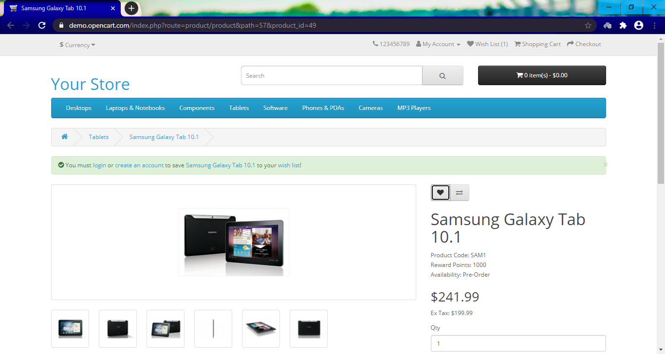

**Step 14 :** Close the success ribbon message on the page.

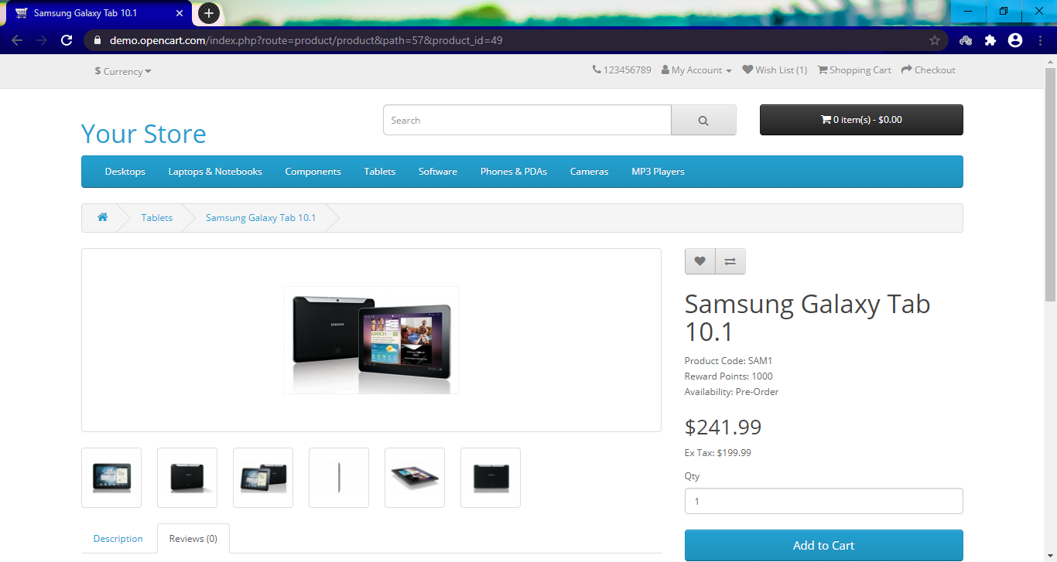

**Step 15 :** Click on "Wish list" link.

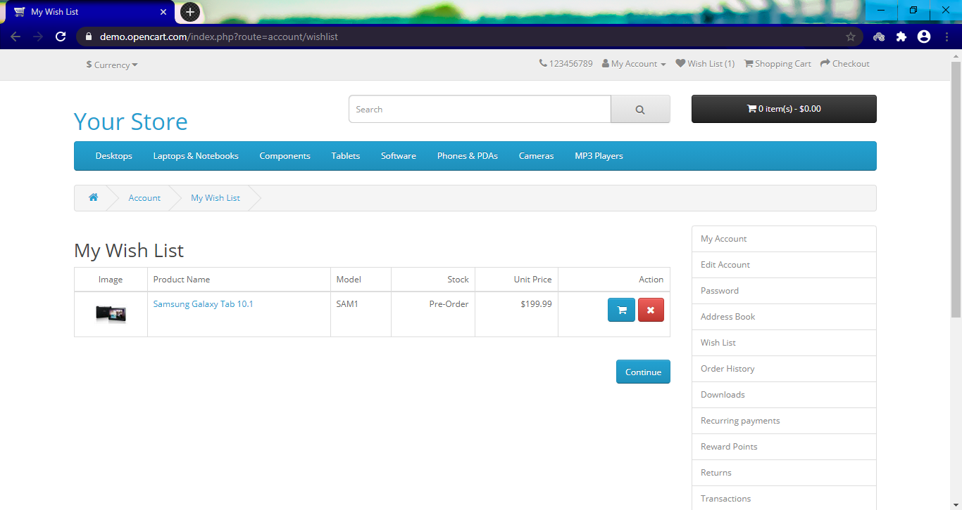

**Step 16 :** Click on "Pound Sterling".

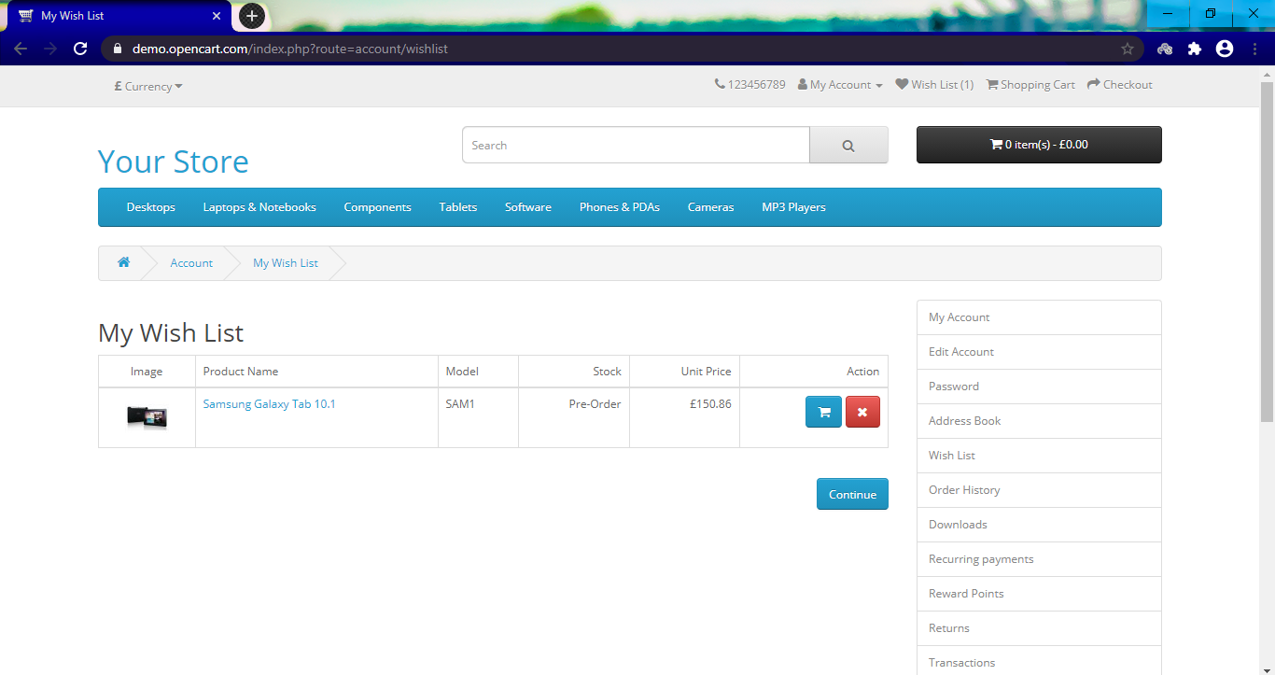

**Step 17 :** Retrieve the value and display it.

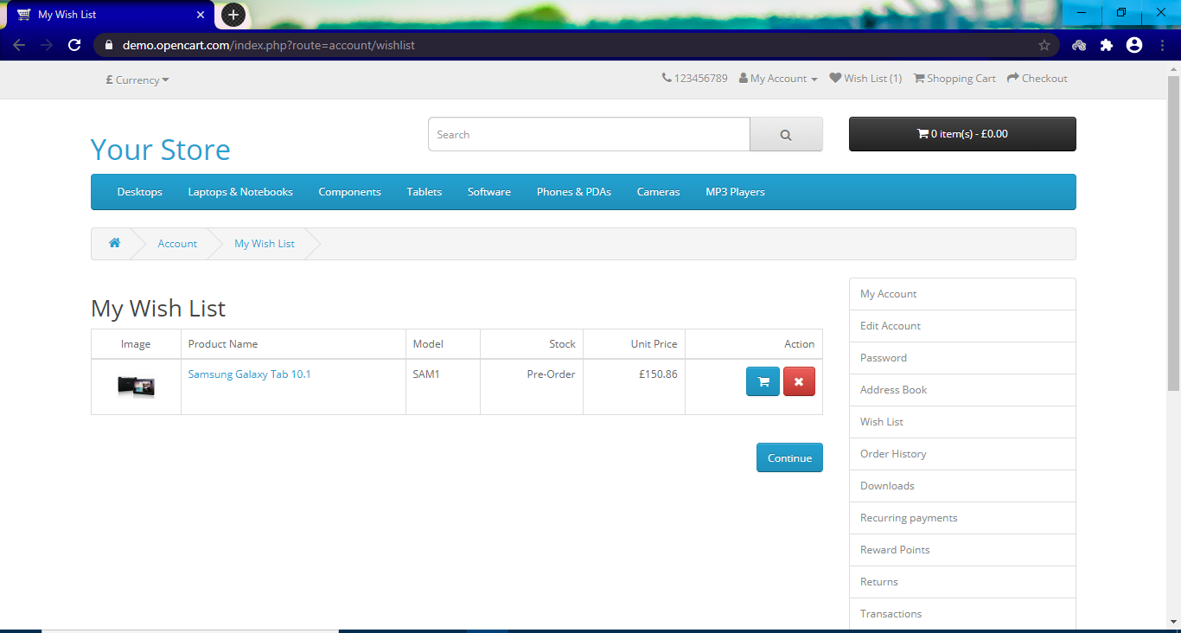

**Step 18 :** Click on "Euro".

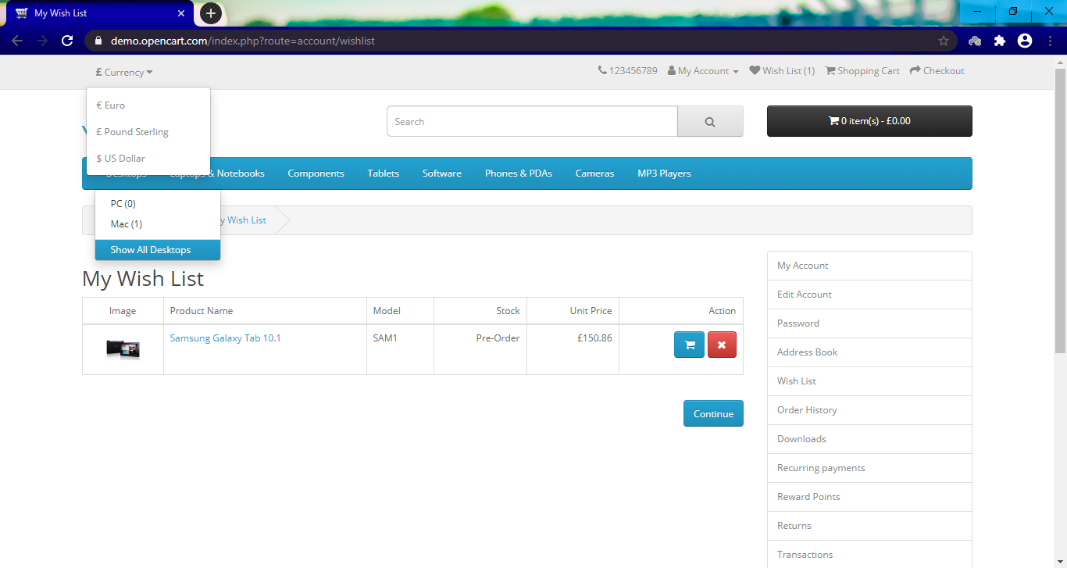

**Step 19 :** Retrieve the value and display it.

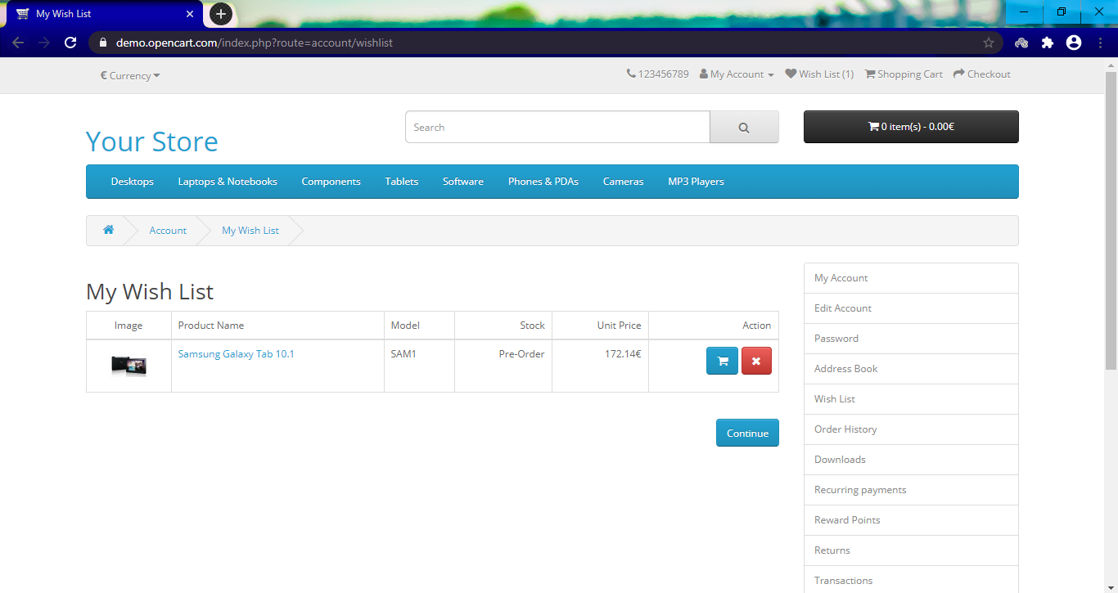

**Step 20 :** Click on "US Dollar".

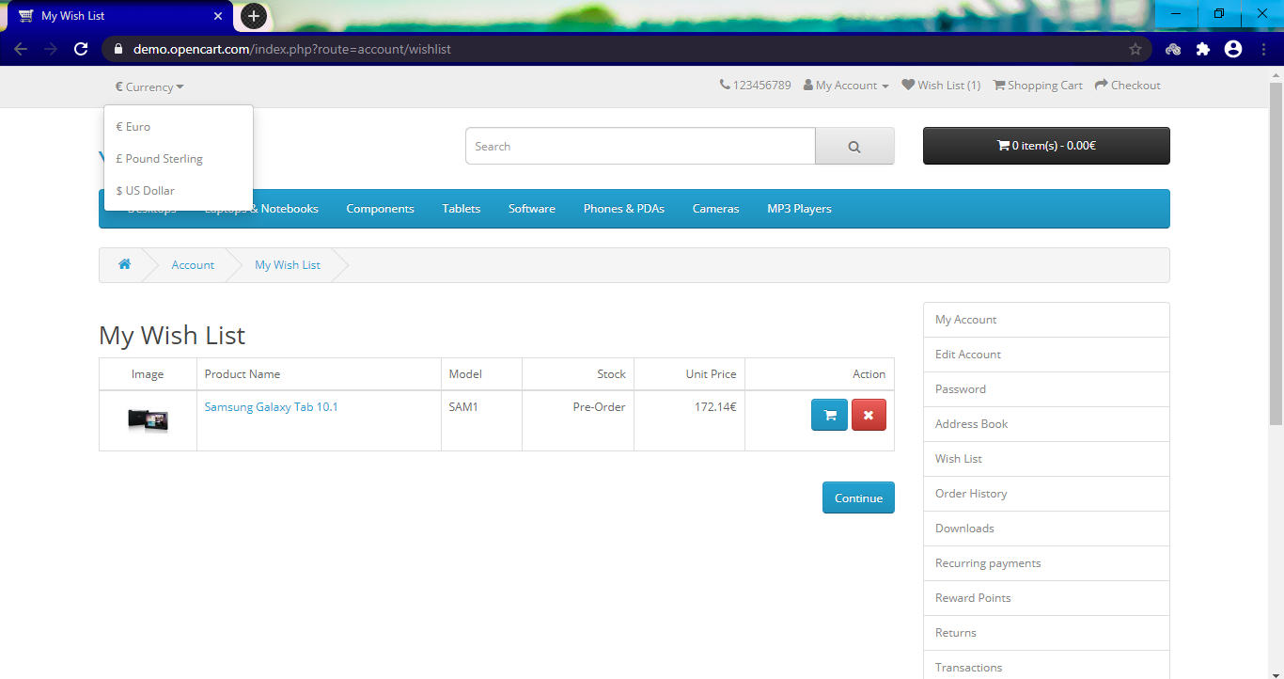

**Step 21 :** Retrieve the value and display it.

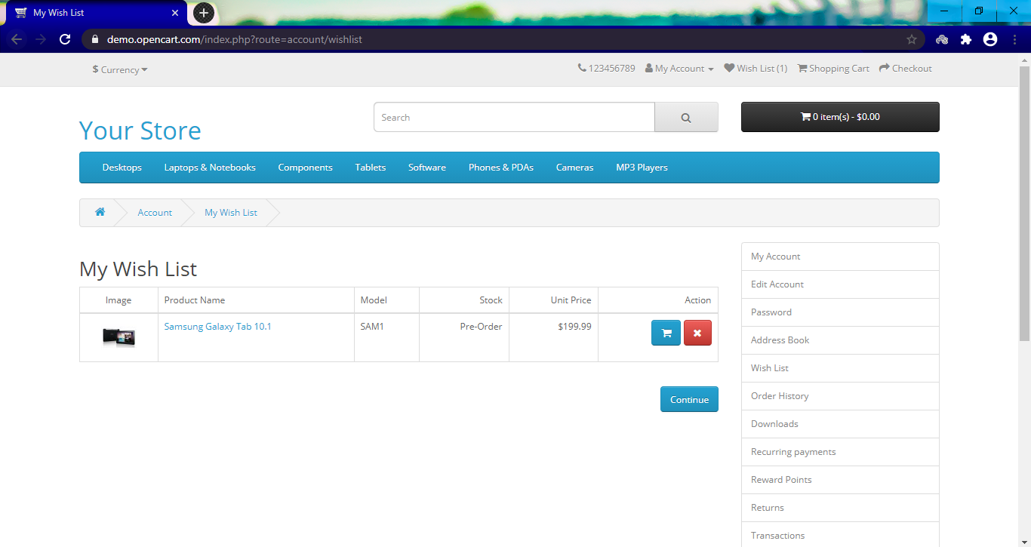

**Step 22 :** Click on "Add To Cart" icon.

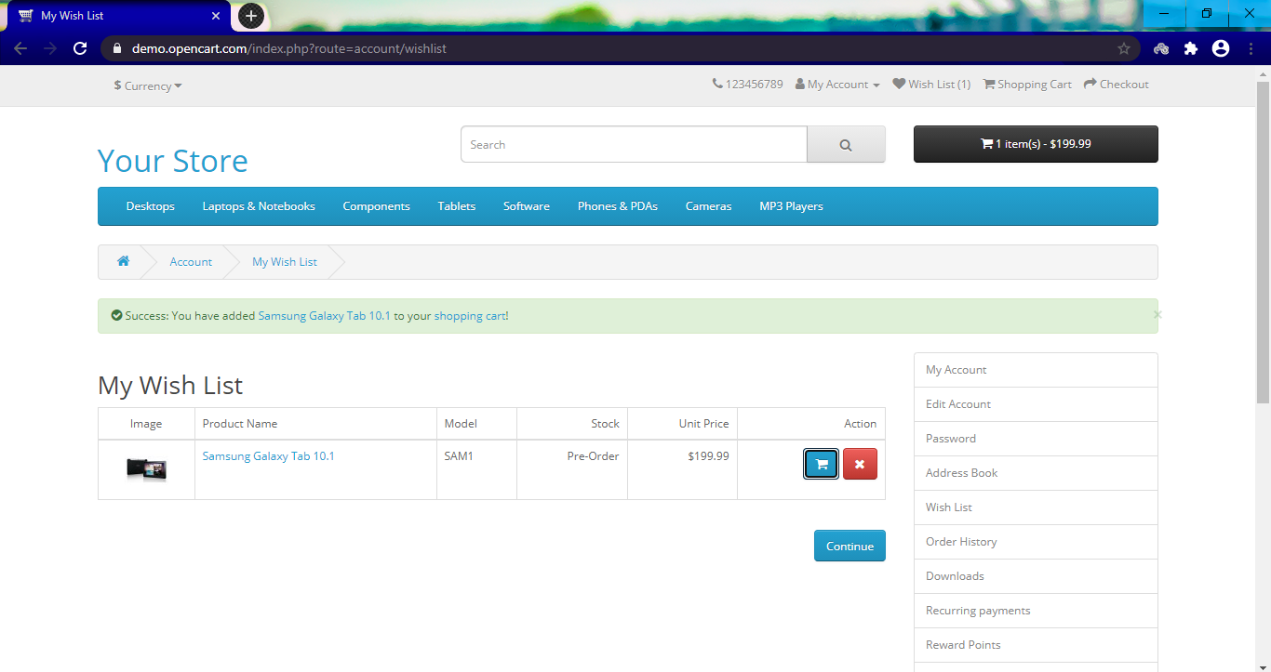

**Step 23 :** Close the success message on the page.

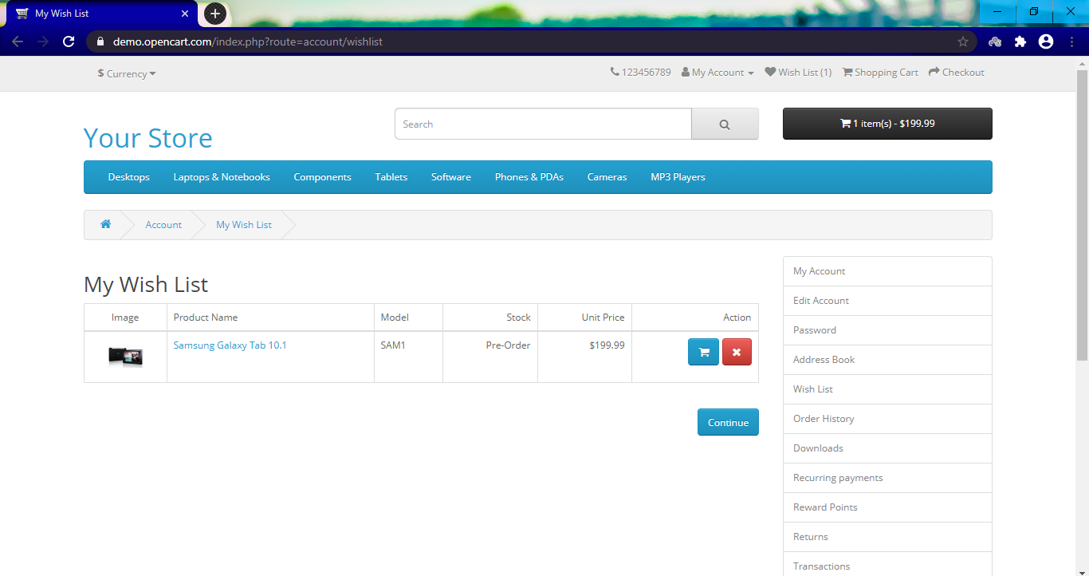

**Step 24 :** Click "Remove" icon on the product in My Wishlist page.

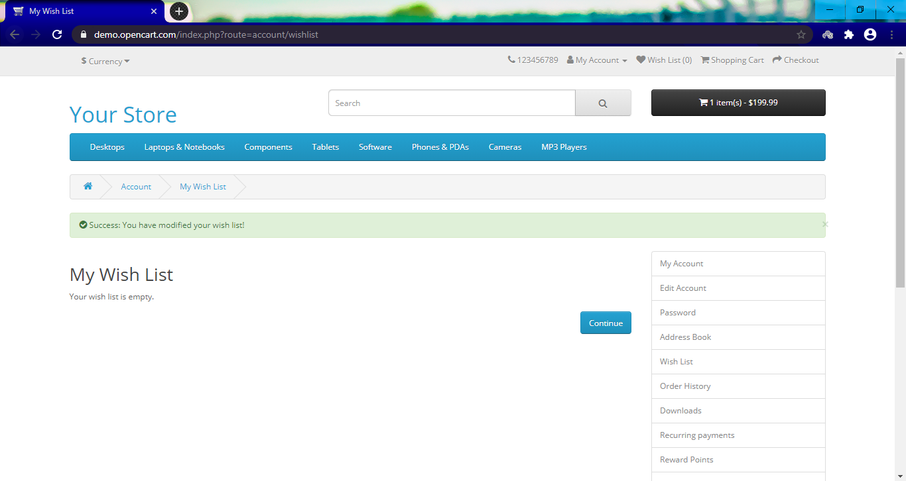

**Step 25 :** click on continue.

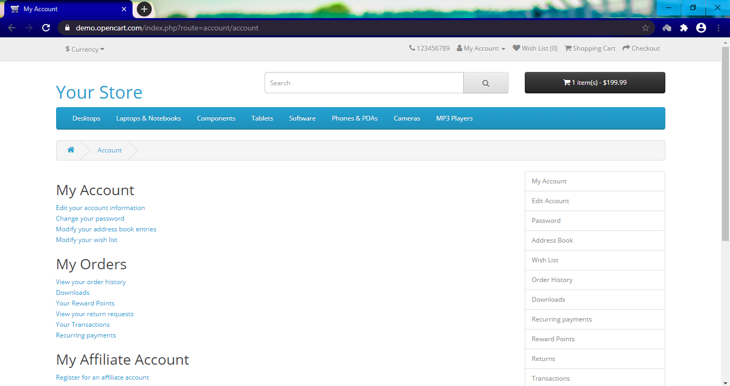

**Step 26 :** Click on "Logout ".

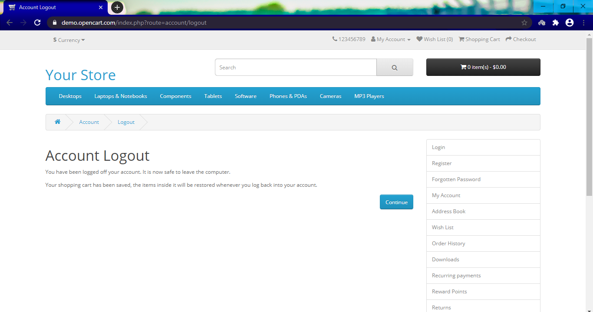

**TC02 - Product Comparison**

**Step 1 :** Launch Open Cart application <http://10.207.182.108:81/opencart/>



**Step 2 :** Click on "Login" Link.



**Step 3 :** Enter Email Address and Password and click on "Login" Button.

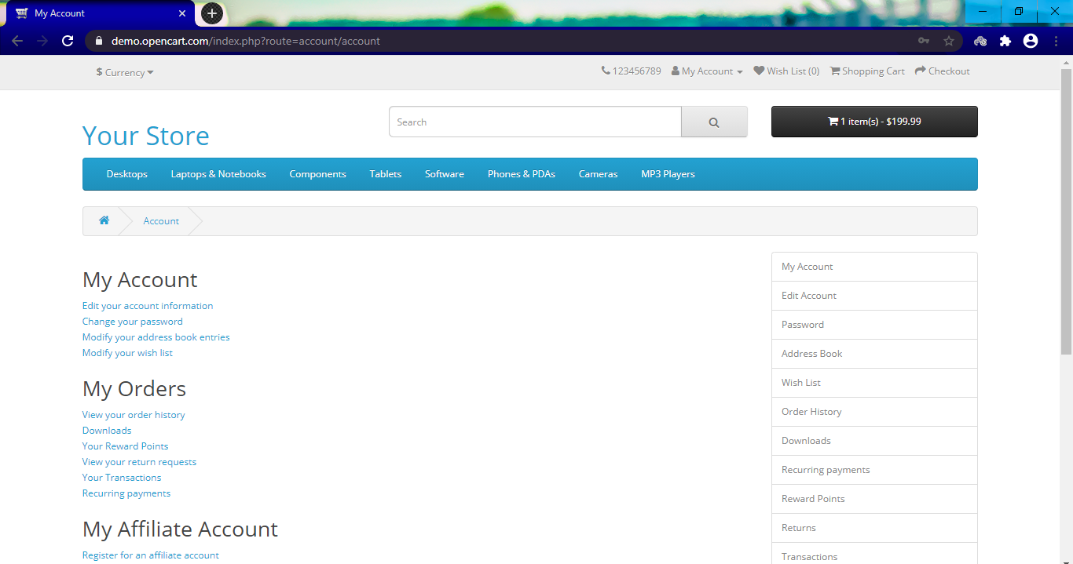

**Step 4 :** Enter the key word in search text box on top right of the page. Hit Enter button only and no icon click.

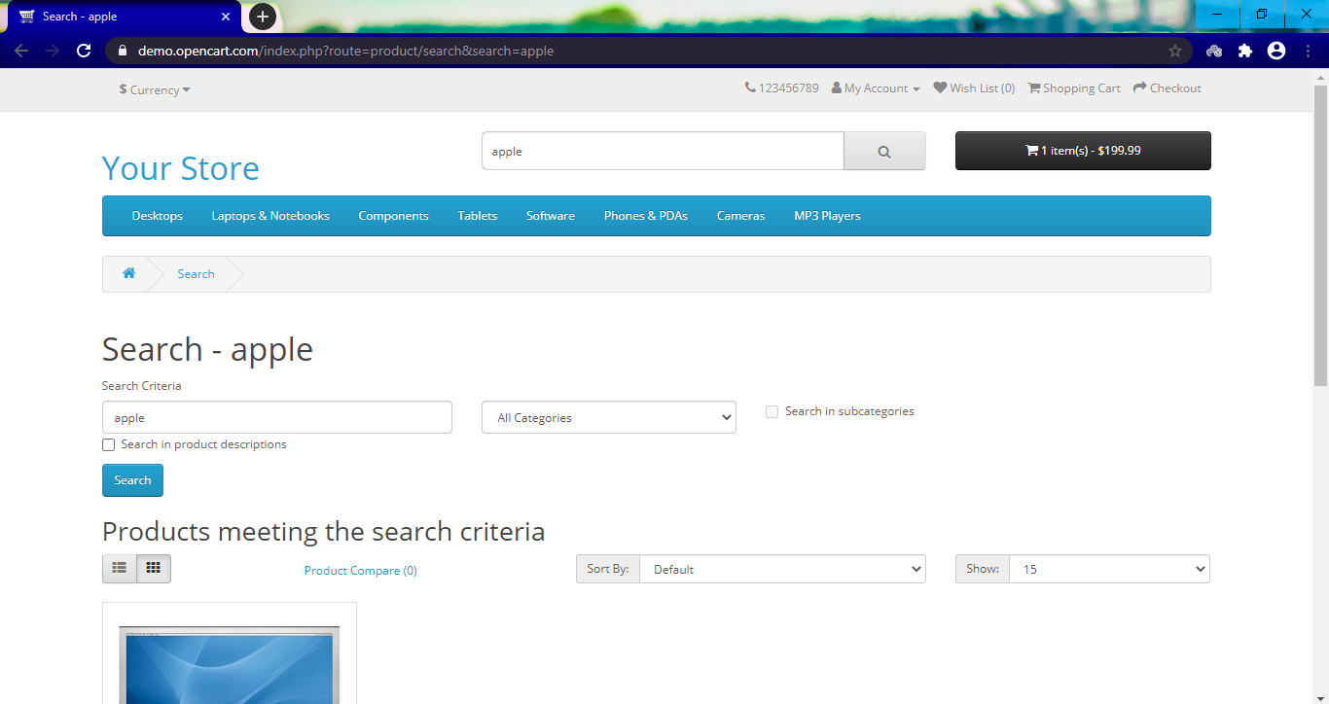

**Step 5 :** Select "Monitors" under Components in the drop down. Check "Search in sub categories" and click Search.

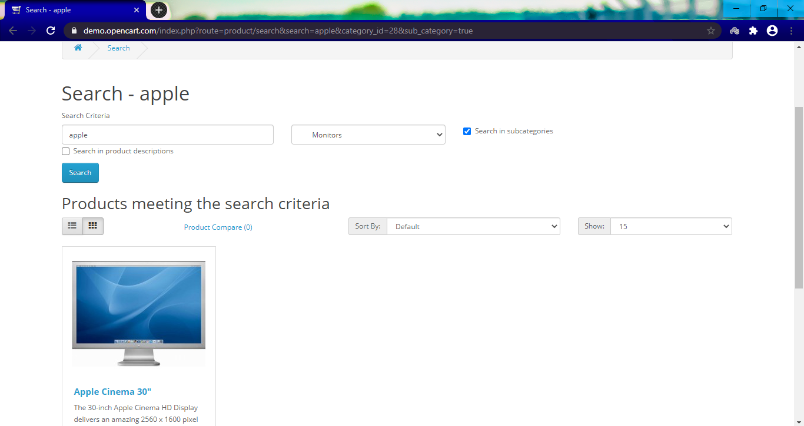

**Step 6 :** Click on "Phones and PDA's" tab.

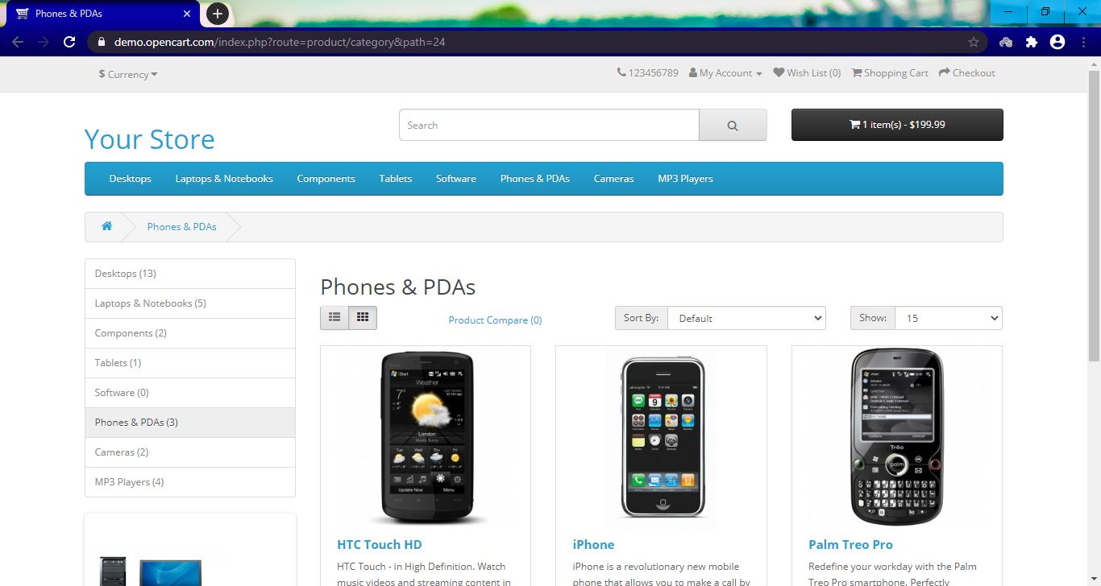

**Step 7 :** Sort from the "Price (High > Low)" for the page.

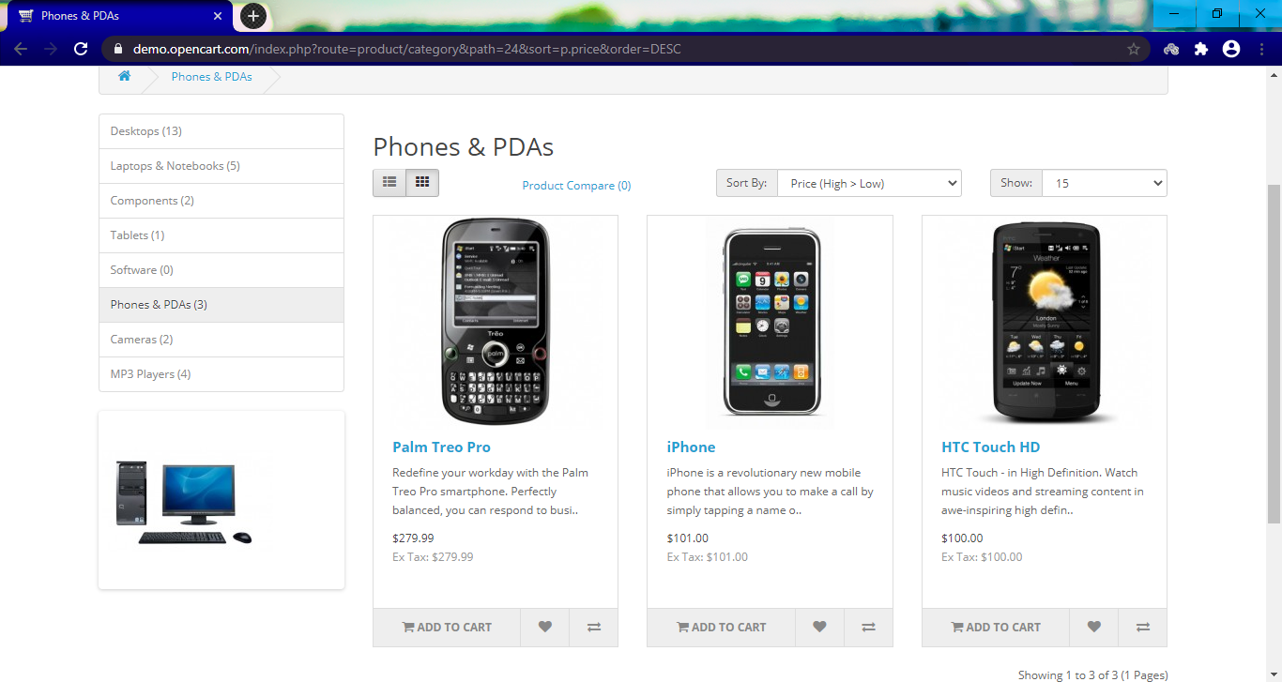

**Step 8 :** Click on "Add to Compare " for the first three phones" and click on Close button.

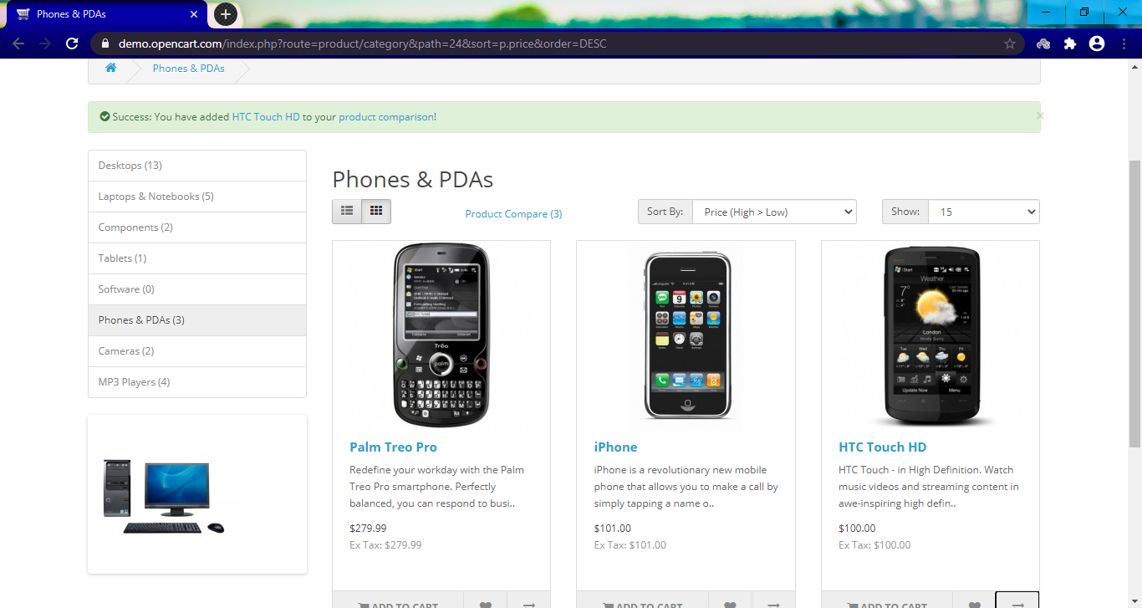

**Step 9 :** Click on "Product Compare".

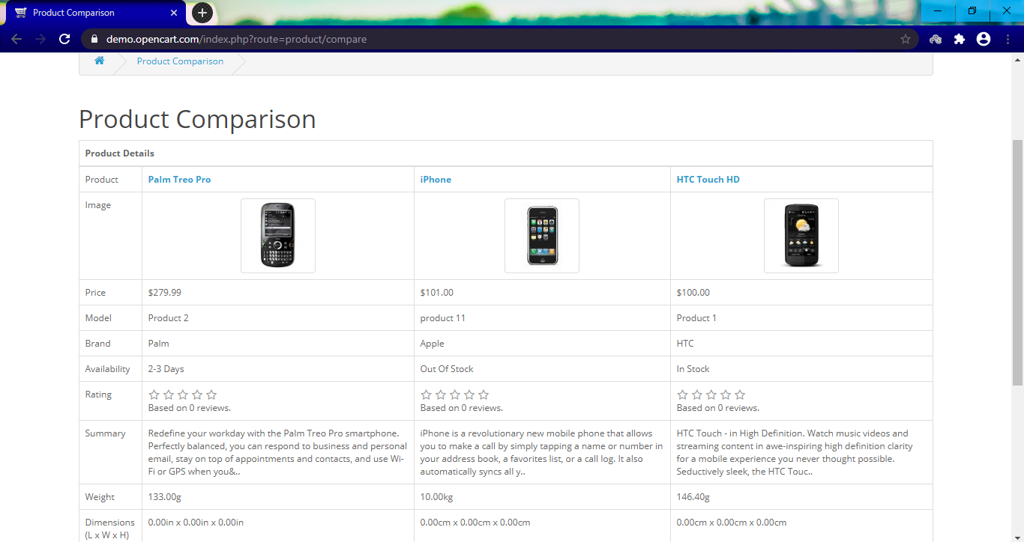

**Step 10 :** Click on the first phone link on the page.

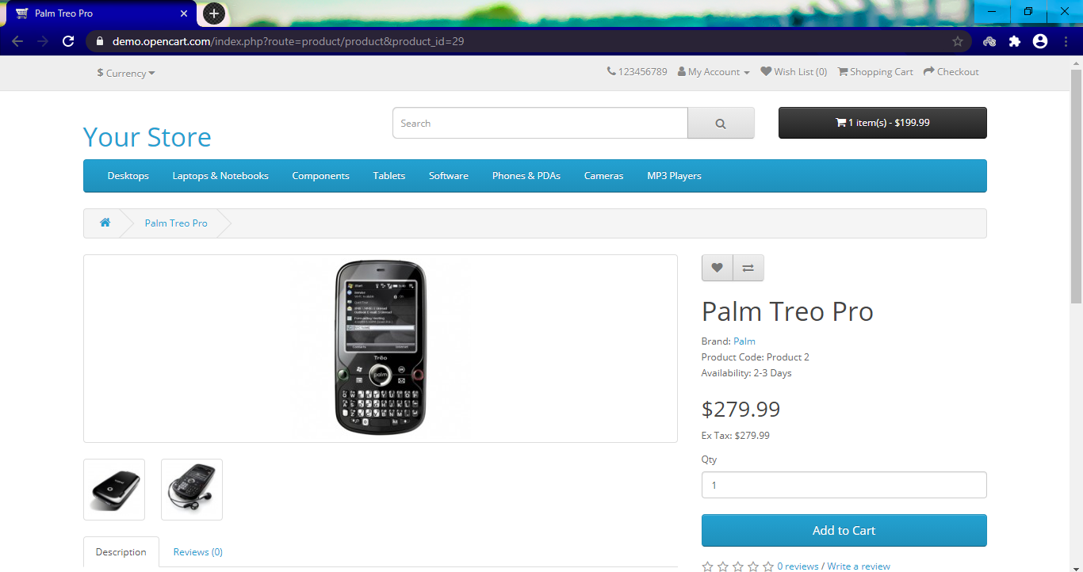

**Step 11 :** Check the fifth feature in the description section of the phone and write into flat file,This step is not available in opencart.

**Step 12 :** Click on "Add to Cart".

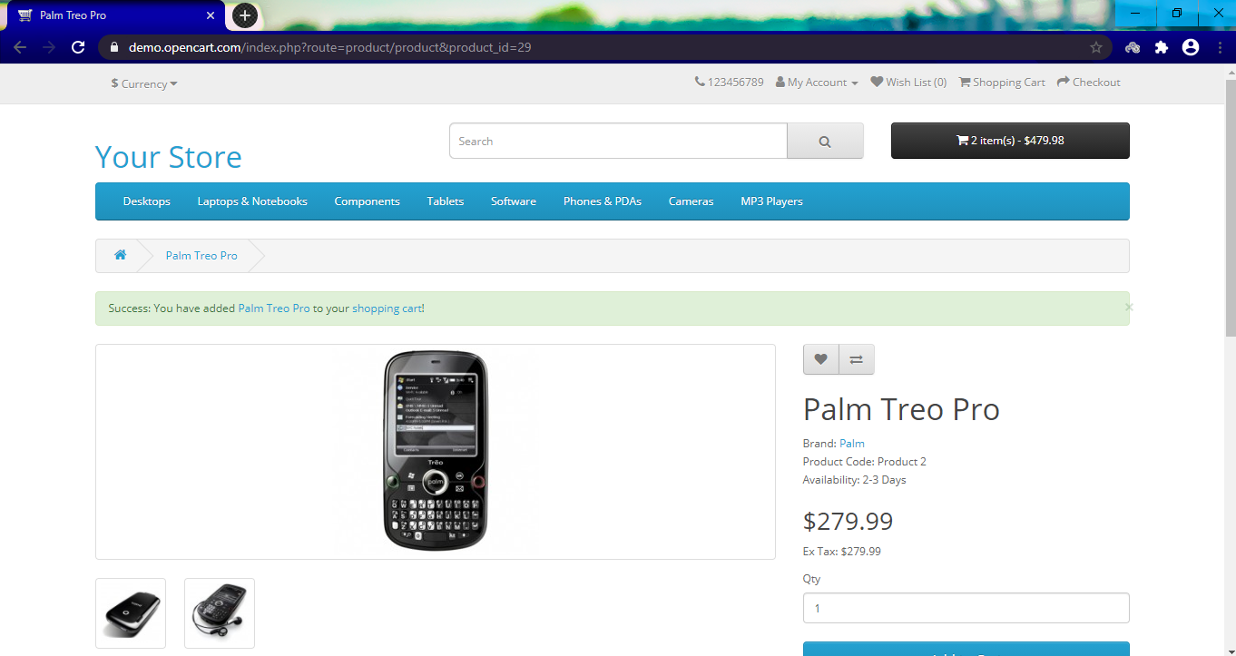

**Step 13 :** Click on "Shopping Cart" displayed on ribbon message.

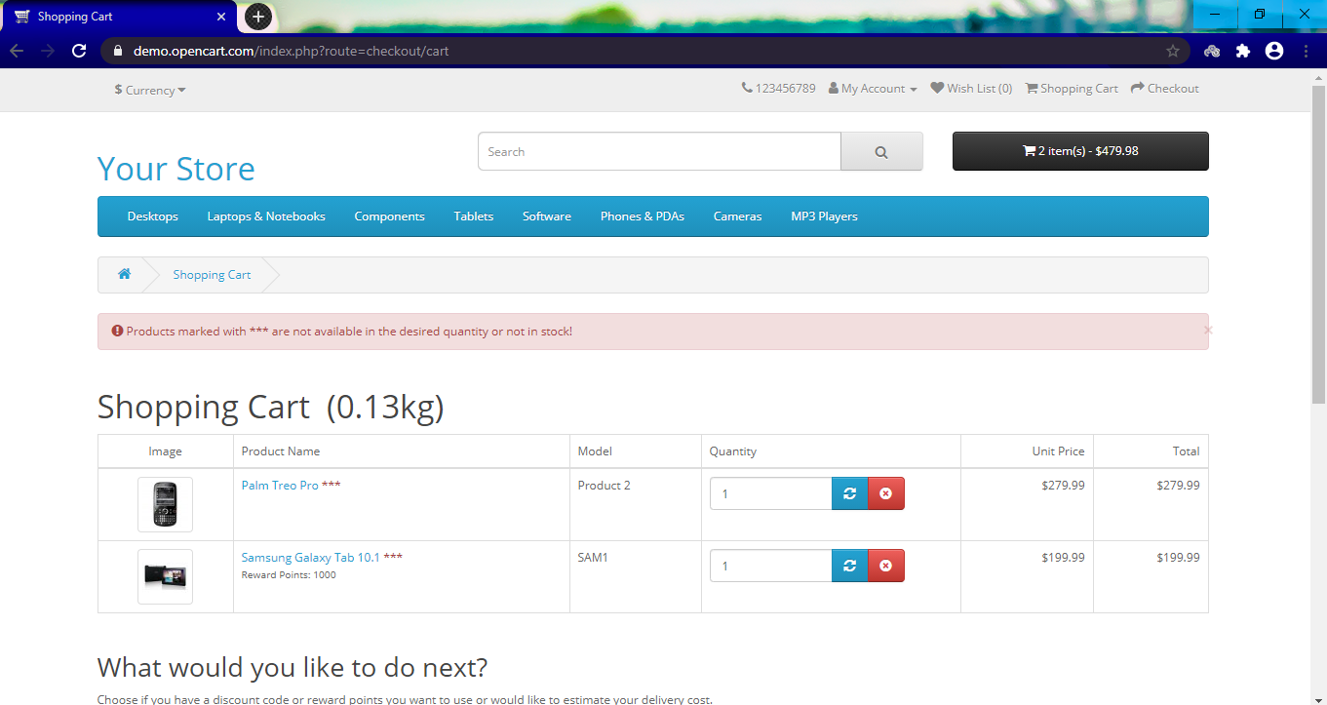

**Step 14 :** Click on Check out button.

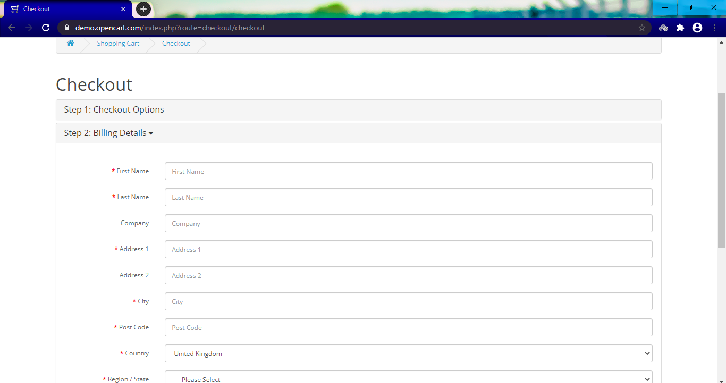

**Step 15 :** Click on Continue buttons (2nd, 3rd and 4th).

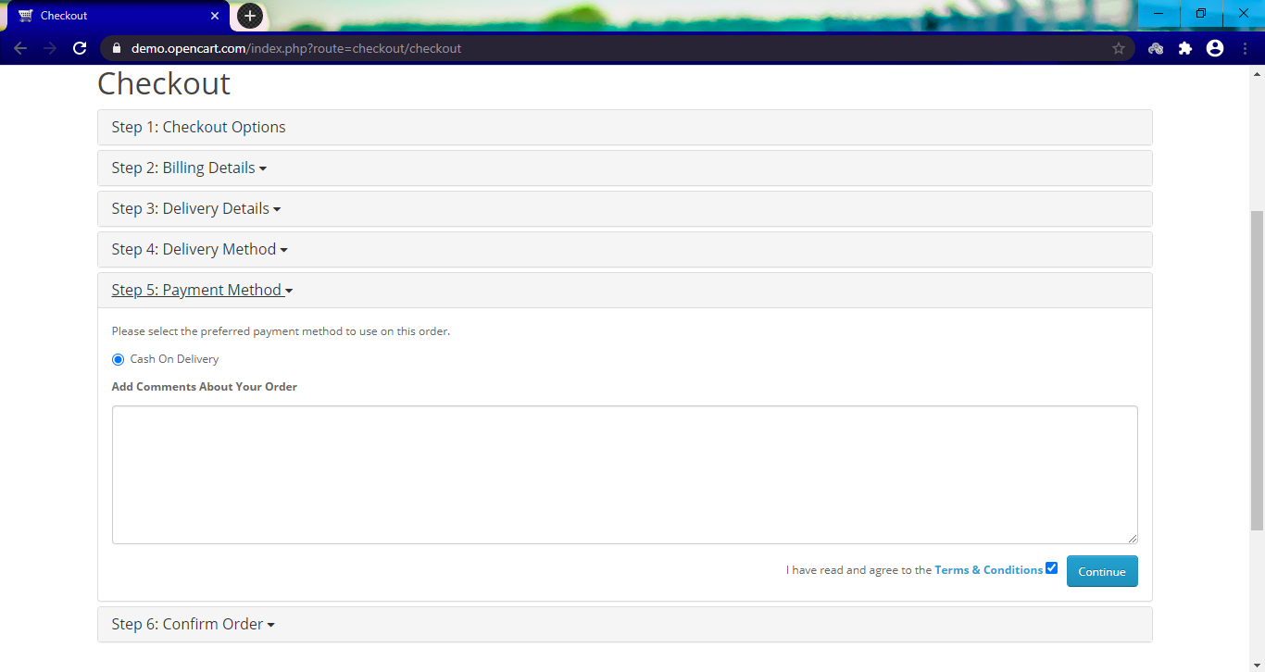

**Step 16 :** Check the Terms and Conditions Checkbox and click Continue.

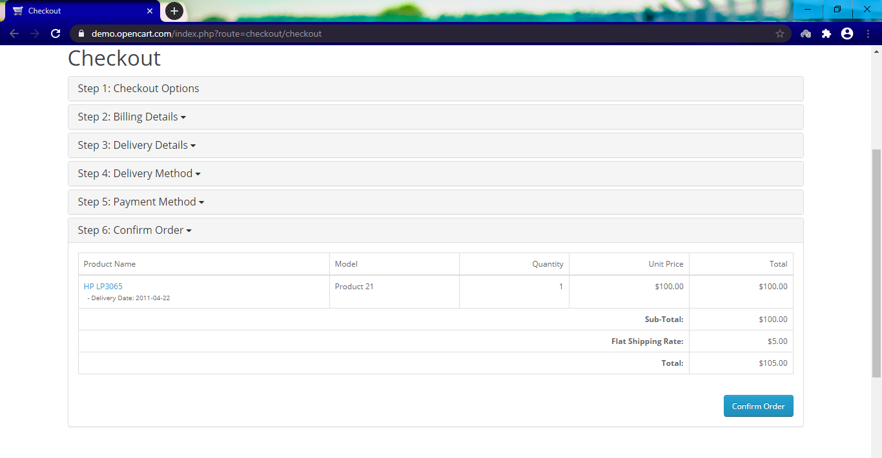

**Step 17 :** Click Confirm Order.

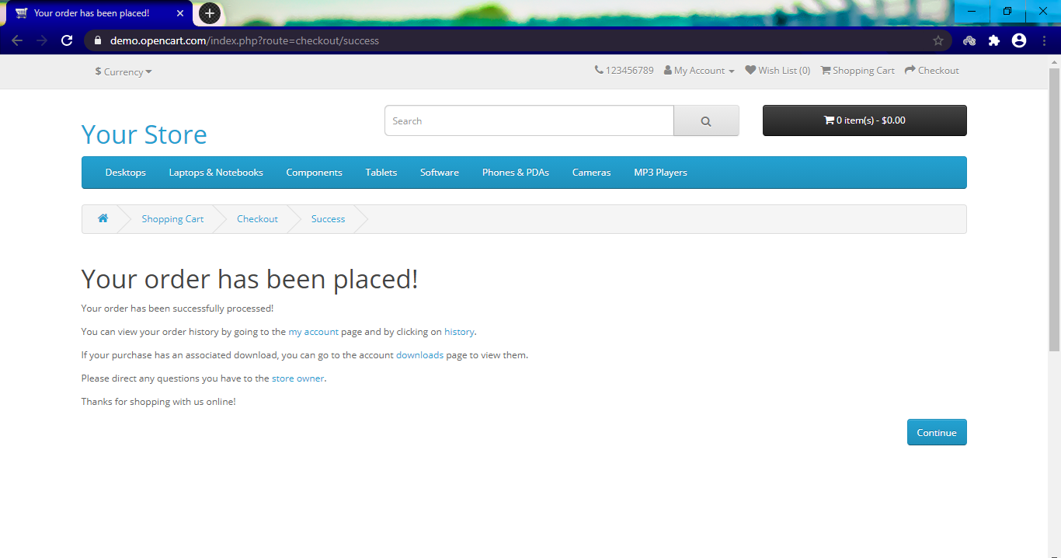

**Step 18 :** Click on browser Back button.

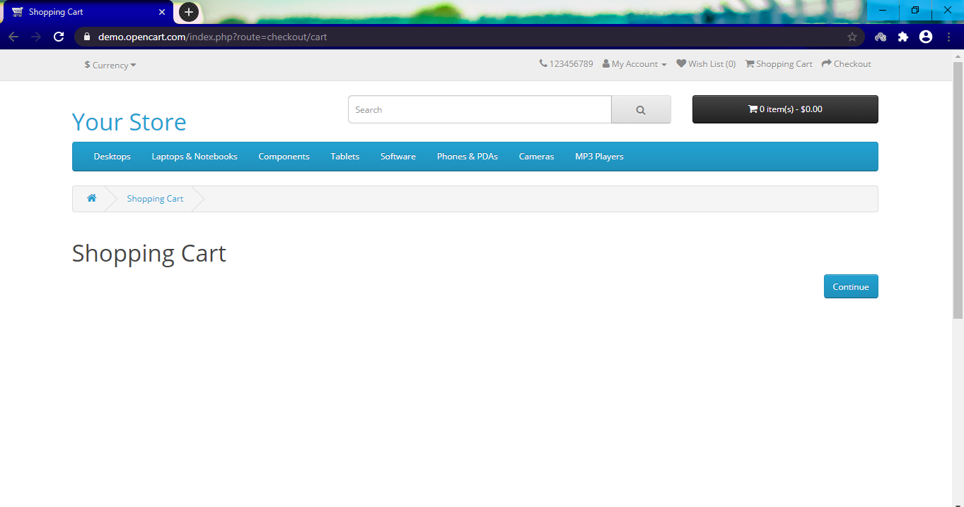

**Step 19 :** Click on "Order history " from "My account "tab.

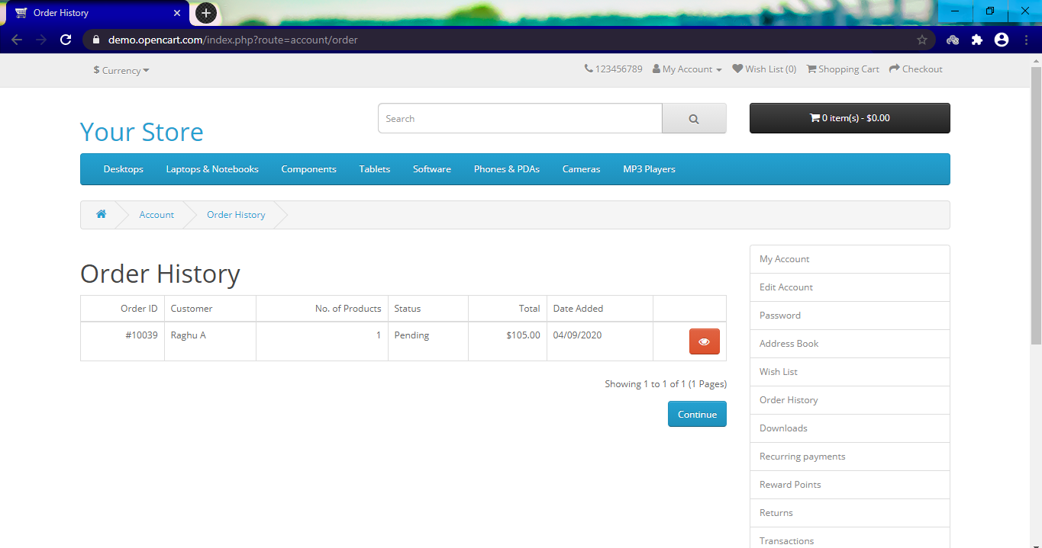

**Step 20 :** Click on "Subscribe to news letters".

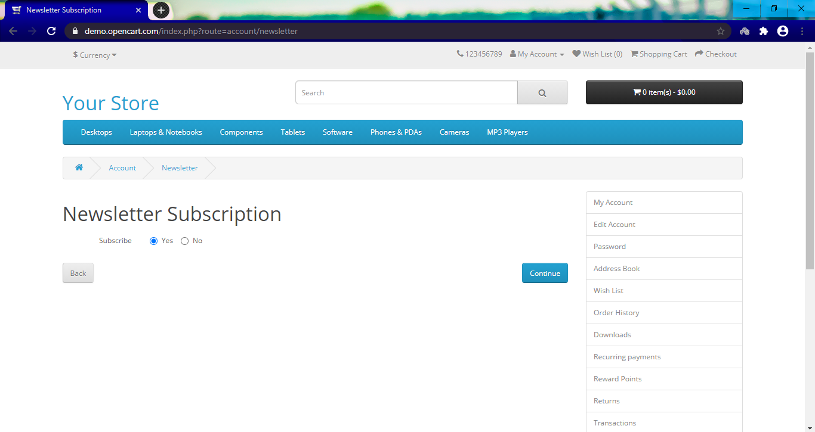

**Step 21 :** Click on Extras -> Specials in the footer.

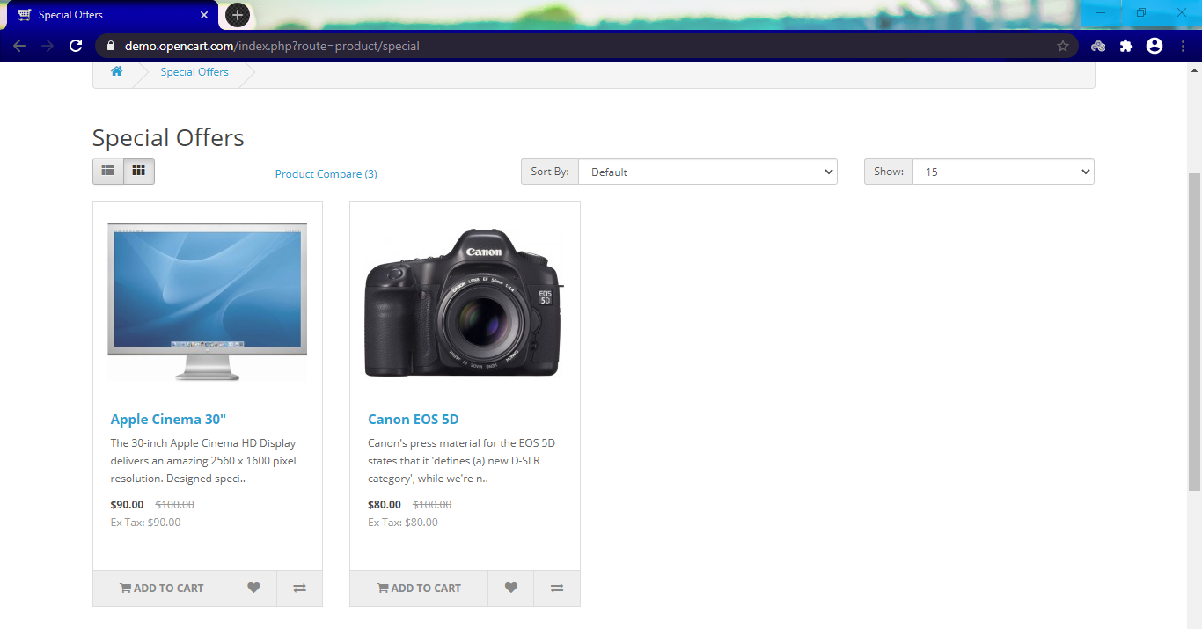

**Step 22 :** Click on List (or) Grid whichever is enabled.

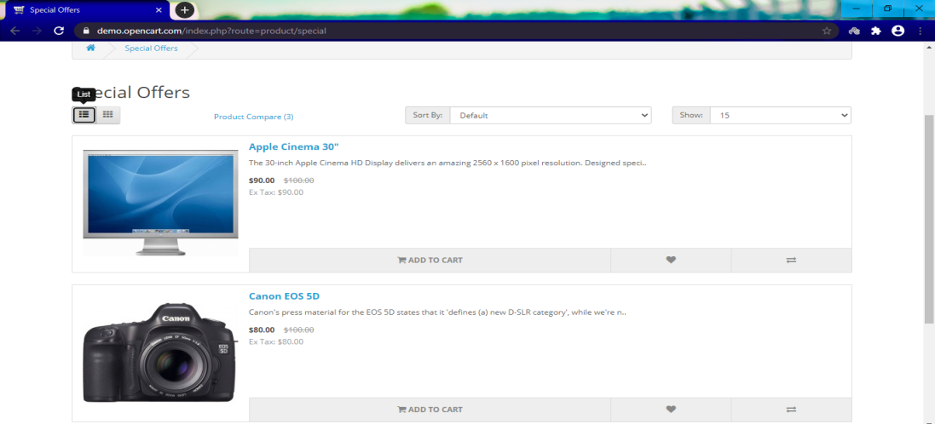

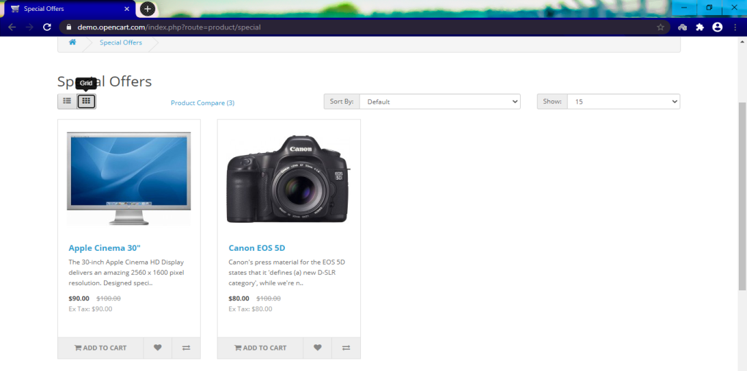

**Step 23 :** Click on "Logout ".

